Chapter 4

Result and Analysis

This chapter presents all the data gathered, the process undertaken in planning, requirements gathering, design, implementation, testing, and evaluation of the results of the proposed system in EARIST clinic department.

**Initial Planning**

In this phase, the researchers prepared random questions for the interview (see Appendix D) to identify the requirements and specification needed for the development of the proposed system, all the tasks that should be done for the whole research process were all defined in the Gantt Chart (see Appendix A) this was used to specify all the tasks together with the deliverables given for the specific time and schedule. Lastly, it was in this phase that the researchers scheduled a survey with the school nurse in charge in relation to the current standing and problems encountered in the existing manual process of the school clinic’s paper work.

**Requirements Specification**

In this phase, all the requirements were specified, the modules and functions were identified and gathered including the primary users of the proposed system.

**The Users**

Admin

The admin of the system is the nurse in charge of the clinic. The admin is the one who is in charge of setting up clinic staff’s account, medicine inventory, and the reports. Also, the admin can view all the reports, such as: total number of users registered to the system, patient lists and the total number of appointments registered to the system. After which, the admin is also responsible for updating some records of the system.

Staff

The staff is the primary user of the proposed system, the staff is in charge for registering the record of the patient information, medical history of the patient, prescription and can view and manage medicine inventory status. The staff can also query and view the patient’s profile and records.

**System Modules and Functional Requirements**

Based on the requirements and data gathered in relation to the users’ roles, they can perform the modules defined in the system including the features and functions of each modules. The tables below will specify the information elaborated in the users’ role above.

Admin Module

In this module, the admin is in charge of registering new staff user, manage the medicine inventory, view patient profile, view medical history record, view patient prescription and gather the monthly and annual report. Under the medicine inventory, the admin adds the list of medicine, description, and stock of the available medicine. The admin can also check whether the medicines that are purchased were expired or not, and also the admin can add information from the vendor where the medicines are purchased. Also, in a scenario where the doctor is available when a patient visits the clinic, there is a check-up module included to track the check-up details. Lastly, under the Manage Patient Profile, the admin is also capable of updating patient profiles and delete redundant information. The detailed list of functionalities for the module (see table 4.1). The school year were also set up by the administrator.

Table 4.1 Functional Requirements – Admin Module

|  |  |
| --- | --- |
| Function | Description |
| Log in | In this function, the admin will provide the correct login details such as the user name and password. Also, the admin needs to log in first then perform the functionalities of the system. After the admin logged-in, the new user session will be established. The proposed system will alert if an unauthorized credential is supplied. |
| Register Account | This function allows the admin to add and manage new employee or user that can access the system. |
| View Patient Detail   * medical history record * prescription | The admin can view and delete redundant patient records, prescription, and medical history to the system. |
| Create Reports   * Monthly report * Annual report | In this function, the administrator will gather all the reports from the system, which includes: School Year, Semester, Date, Medical Case, and Outbreak. |
| Manage Medicine Inventory | This function allows the admin to list all the medicines that are available, date and time of purchase to check whether it is expired or not. Then the vendor or supplier details to give track of the vendors details. |
| Check-up | In this function the admin can manage check-up information and automatically informs the professors and guardians of students when he/she drop by at the clinic thru e-mail. |

Staff Module

The staff module includes all the functions that can be done by the clinic staff. This module includes function for adding new patient, add treatment record and add an appointment for the patient. The table 4.2 will describe briefly each of these functions.

Table 4.2 Functional Requirements – Staff Module

|  |  |
| --- | --- |
| Requirements | Description |
| Log in | In this module, the clinic staff will log in using the authorized credentials. Once logged in, the staff will be able to perform the rest of the functions. |
| Add Patient Details | This function will allow the staff to add a new patient record to the system. |
| Manage Patient Medical History | This function allows the staff to manage the existing record of the patient including the medical records of the patient. |
| Manage Medicine inventory | The staff will be able to manage medicine inventory and check the medicine stock. |
| Manage Patient Prescription | The staff can manage the prescription record of the specific patient according to the result of the doctor’s check-up towards the patient. |
| Check-up | In this function the staff can also manage the check-up details of the patient’s visitation. |

**Analysis and Design**

In this phase, the system requirements that is gathered will be formulated to accomplish by establishing to what the proposed system can do, according to the requirements and expectations of the proposed system’s end users. The modelling of these requirements will then perform to demonstrate the understanding of the requirements.

Conceptual Diagram

To give further understanding to the proposed system, a conceptual diagram is shown (see figure 4.3). Essentially, important data shows an illustration depicting the arrangement and relationships of the entities within the system using a variety of appropriate symbols that are easily understood.

Admin Entity

The admin will create the clinic staff’s details to register and activate the account so that the staff can access the system. The admin can view and delete redundant data and information that is being inputted to the system such as patient details and staff details. To create patient profile, the clinic staff will be the one who will encode that information. After which, the system will list all that information for easy access in each patient data. The admin can manage the medicine inventory to keep track on the remaining medicine and remaining stock to know what particular medicine should be purchased. The admin can also view all records, users that logged into the system, number of cases each school year and then create an annual report based on the data within the proposed system.

Staff Entity

The staff supplies all the data needed to generate patient profile. The data include the patient detail, and prescription detail based on the result from the doctor’s check-up towards the patient. The appointment details were also supplied by the staff, this module is one of the main features of the proposed system.

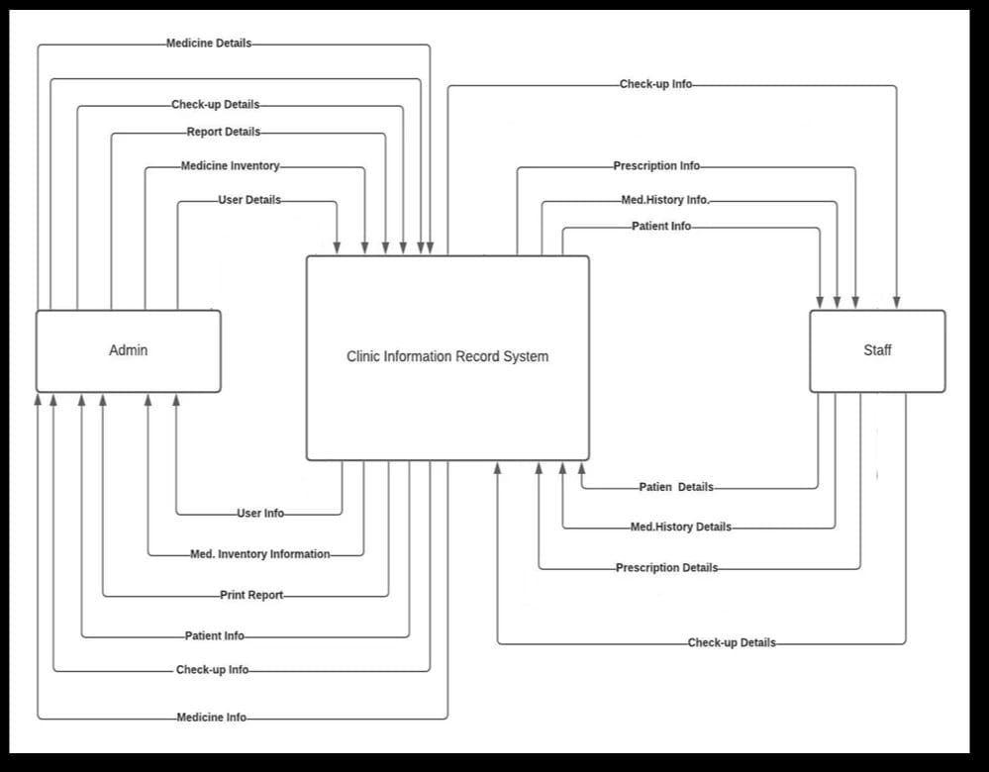

Figure 4.1 Context Level Data Flow Diagram

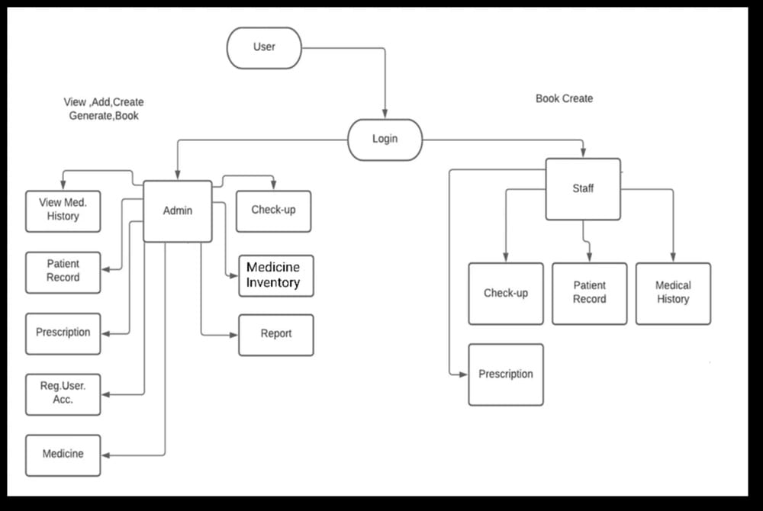

*Level 1 Data Flow Diagram*

Figure 4.2 Level 1 Data Flow Diagram

Based on the Context Level Data Flow diagram shown in (Figure 4.2), Level 1 Data Flow diagram (Figure 4.2) shows the major process of the proposed system. The diagram elaborates the flow of the data and information that is associated with each process and entities, in which these data and information are supplied by the proposed system to each entity. The major processes are registering user account, add patient, check-up, generating reports and managing medicine inventory. The data from the result of the consultation until treatment process were also stored in the system. The entities are the admin and the staff.

Use Case Diagram

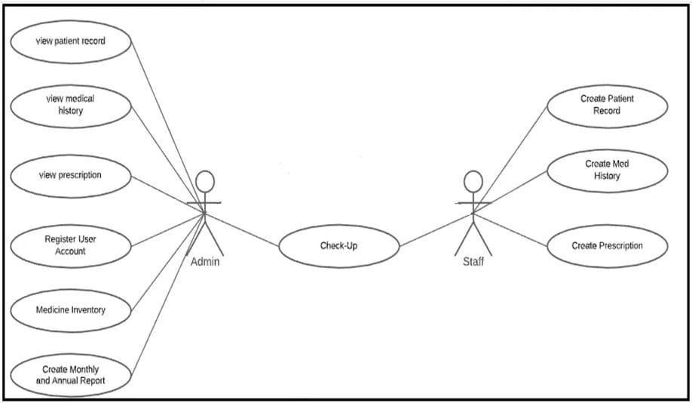

Figure 4.3 Use Case Diagram

To specify the context of the proposed system, a use case diagram is presented (see figure 4.3). There are two (2) participants represent as a user to capture the requirements in the gathering stage.

*Admin.* The admin creates and define each user registered in the system, manage all information that is being inputted including the management of the medicine inventory. It is also the duty of the admin to maintain the system and to plan for the responding outages and other problem that the system may encounter. In addition, the admin can search and view student records and profile. The admin will also create for the staff account, non-active user account can be disabled by the admin also. In short, the admin is in charge of managing the whole system to make it more organized and easier to use. If there is a need to update the username and password of the registered user, the admin is also capable of doing so.

*Staff*. The staff will create or add new patient information. Also, they can search and view patients profile including the medical history of the patient and prescription information of the patient. In short, the staff can view and manage some information that is being inputted to the system as well.

**Database Design**

*Logical Database Design.* The logical database diagram will illustrate the entities needed

Figure 4.4



Figure 4.4 Logical Database Diagram

The entities in this diagram (see figure 4.3) constitute the information requirements gathered during the requirements specification phase. These entities became the basis in creating the physical database design. Additionally, it reflects how entities are associated with each other. The logical database design was transformed as a conceptual schema of the application domain into a schema for the data model underlying a particular DBMS. It also helps in determining what data and information were needed to be keep in track.

5*Physical Database Design.* The figure shown if the Entity-Relationship Diagram of ­­­­­­the proposed system (see figure 4.5).

Figure 4.5 Physical Database Diagram

The Entity-Relationship Diagram is the actual database structure of the Clinic system. Additional tables, such as relationship tables and fields were created to satisfy the rules and information requirements. The main tables of the ERD are: patient, medical record, prescription, medicine inventory, check-up, and report.To give a better understanding to the system and the concept, it gives the users a hint to the system. Also, the researchers used the Entity Relationship Diagram (ERD); the researchers showed diagrams in a graphical representation of the system that would describe the relation between the people, object, places, concept and events within the proposed system.

**User Interface Design**

In this phase, the researchers have created an activity flowchart for each user interface (see figures 4.5, 4.6, 4.7) that helped examine and understand the navigation of the system. It is shown in (figure 4.5) the flow of the activities inside the admin module. The system will require the user to log in the correct credentials. After which, once the authentication is done, and once the user has logged in, the admin dashboard will be displayed including the rest of the functionalities will be displayed. Functionalities such as manage patient profiles, create staff account, manage medicine inventory, manage appointments, and generate reports. In patient profile, it allows the admin to update the records, the admin can also register or create an account for the staff of the clinic. The medicine inventory, reports are involved as well.

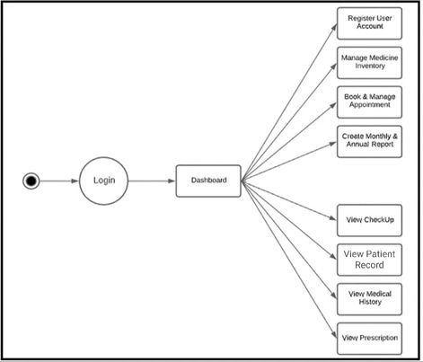Figure 4.6 Activity Diagram – Admin

The activities for the Admin user (figure 4.6) include all the functions under the admin dashboard. The system requires valid log in details from the admin for security purpose, the admin activity diagram shows that the admin is capable of registering new account, view patient profile, generate report, manage medicine inventory, check-up that is being set from the input of the other primary user of the system which is the staff.

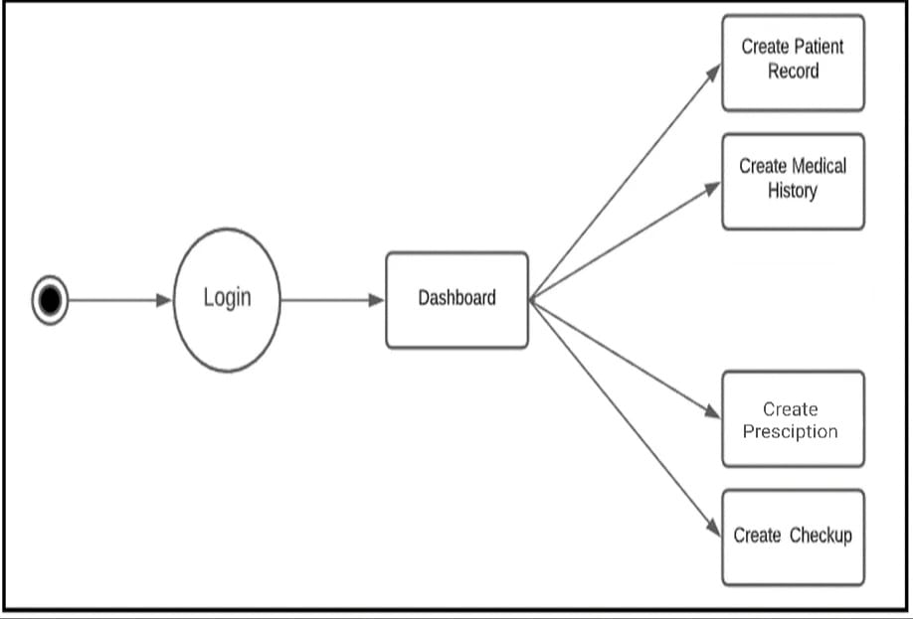

Figure 4.7 Activity Diagram – Staff

On the other hand, the staff logs in to the system and in the systems dashboard, the staff can view manage medicine patient information, create prescription from the result of the patients’ consultations. After which, create medical history records and add the medications to what the doctor prescribes to the patient. The staff is also capable of creating the patient profile and manage the patient record, and is capable of viewing the entire system.

From the activity flowcharts, Hi-Fi prototypes were produced in making the initial dashboard user interfaces for each user type. These Hi-Fi prototypes were used as guide for the user interface designs in the development of the system. In producing the Hi-Fi designs, the researchers will be able to capture the navigation, experienced the look and feel of the system. There will be constant revisions to be done in order to come up with the appropriate user interfaces. The following figures represent the initial dashboard prototypes for admin and staff users.

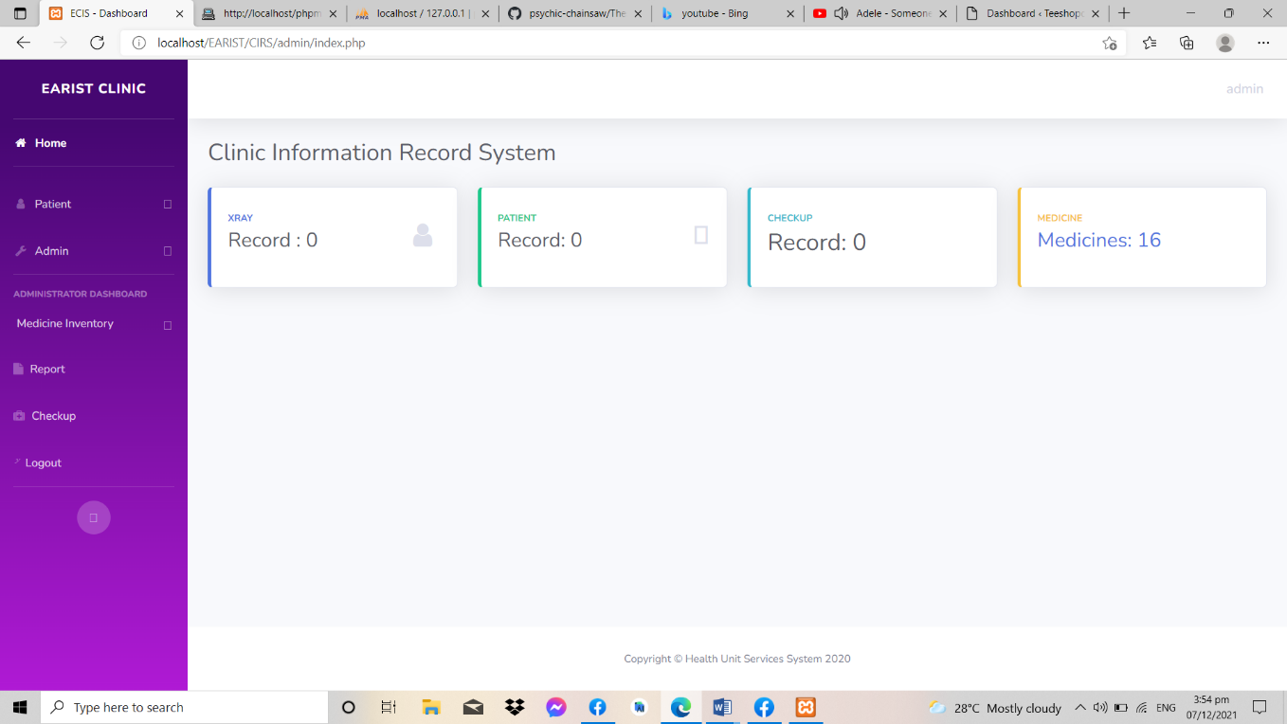

Figure 4.8 Hi-Fi Design – Admin

Figure 4.8 above shows the initial prototype of the Admin dashboard. After which, the left side navigation bar contains the menu items that the admin can manipulate, each corresponding item has its own functionalities. Once the admin has logged in, they can now register a new user that can access the system. The administrator can also update, view and delete each user account that is registered, view patient profiles, create reports, manage medicine inventory and also the admin can view the appointment and check-up details. View the total numbers of registered users, total number of patients and total number of appointments that is being scheduled, all data recorded within the system can also be viewed and tracked by the administrator’s dashboard.

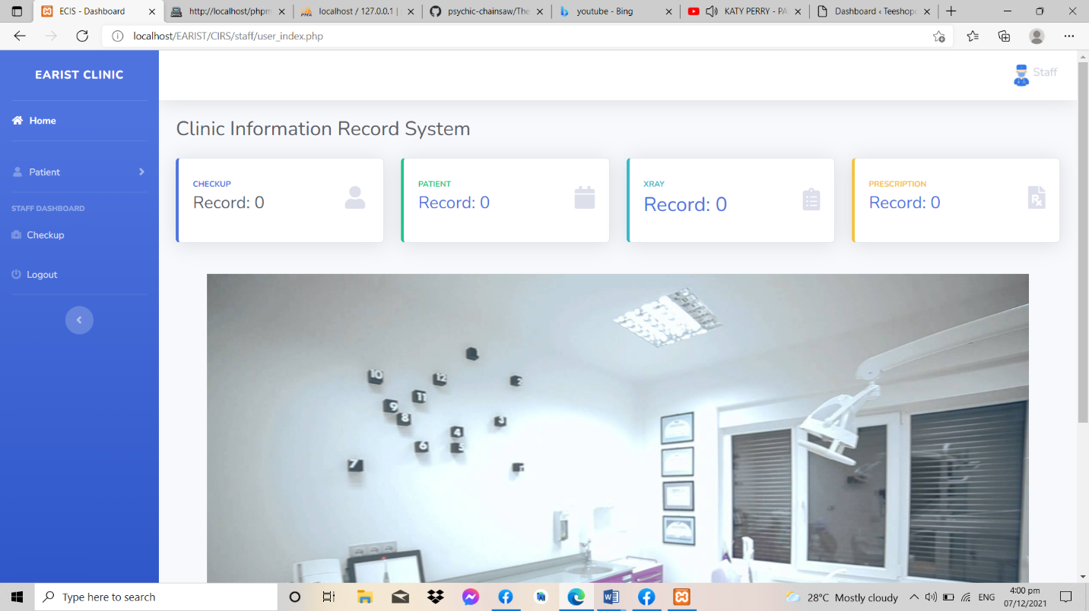

Figure 4.9 Hi-Fi Design – Staff

Here in the staff dashboard design, there were four (5) main menu items that are included in the navigation bar in the left side of the dashboard. Here, all information from the patient will be inputted in this patient profile form. Patient details can also be viewed and managed from this form. After which, prescription details from the result of the consultation will be inputted within the prescription module, the same also goes with the medicine inventory module and check-up module as what figure 4.9 shows.

**Architectural Design**

The three-tier architecture design will be used in the implementation and it will be divided into three-tiers namely; the client tier, application tier, and the data tier. This will allow the users to connect from different location (see Figure 4.10).

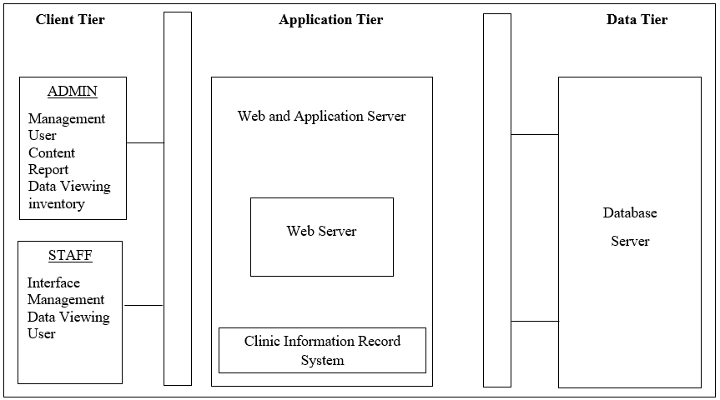Figure 4.10 Architectural Design

The client tier in the top most level is the user interface or the presentation tier. This tier is in charge of translating the all the data that has been recovered from the database based on the actions presented in a way that it can be read and understood by the users. Since the system operates on a web-browser, (Bootstrap framework, HTML 5, and CSS) were used. As what Figure 4.10 showed, each user type was presented separately to determine the interaction between the data tier and get the proper data needed for each user.

Application tier, it controls the system functionality by conducting a detailed processing of data. After which, PHP (Hypertext Processor) script accesses the input from the user and generates an output, and Apache server filters data for a proper. Both will be used to support this tier.

MySQL server is used for the data tier. This store and retrieves all the data from the database. After which, the data will be sent back to the application tier for processing and then passed on to the client tier for information presentation.

**Implementation**

During the implementation phase, system prototypes design will be developed. User interfaces will be developed using HTML 5, CSS, and Bootstrap framework. JQuery will be used also for server-side scripting purpose to implement the functionalities and MySQL will be used to implement the data design. The functions will be presented in the following images.

It is shown in Figure 4.11 the appointment detail list page. To create an appointment, the user needs to click on the “Add Appointment” button, a modal form will appear and the user will then set the appointment. This can be managed by the user in its dashboard, the user can update the record of the appointment or delete.

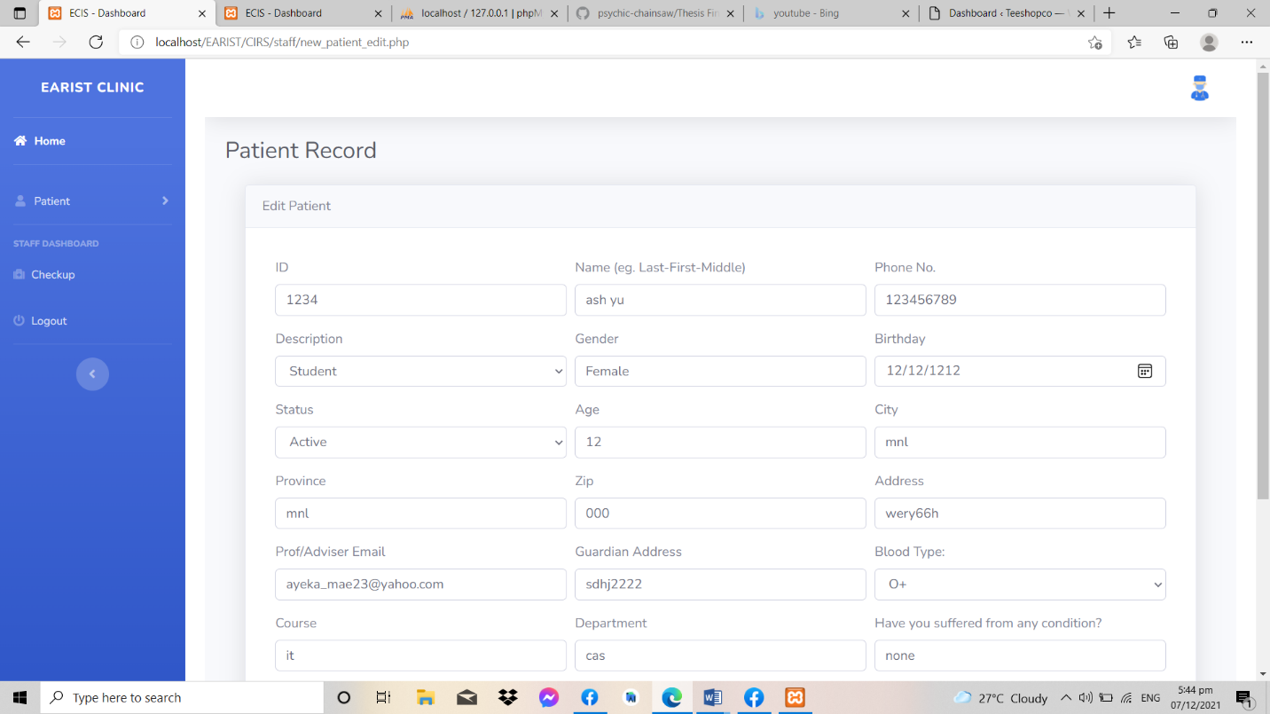

Figure 4.11 – Patient Detail/Record

In this from, both staff and admin can view this from but, only the staff can manage all the record meaning the staff can edit, delete and update the records inputted by the staff itself. While the admin on the other hand, can only view and delete all the record from the patient. Both admin and staff can filter or query to recover the files faster, unlike before it took them 2-3 weeks to recover all file, having the system all files can be gathered within minutes.

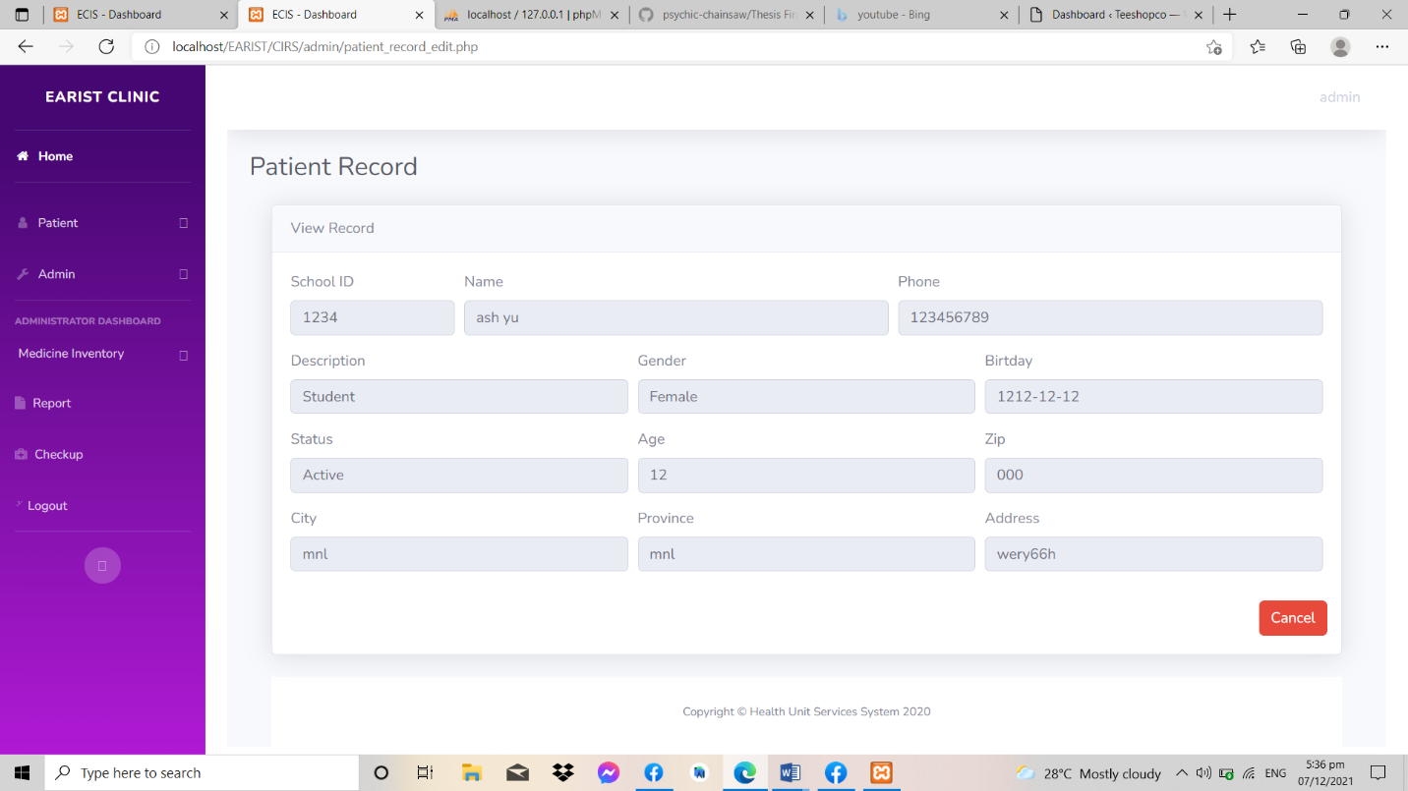

Figure 4.12 – Patient Medical History (Clinic Information Record System)

Patient Medical History, in this form both admin and staff can also view this same form. The admin can view and delete the medical record of the patient, while the staff is the one who will manage all the data from the staff dashboard then stored to the database which both admin and staff can view.

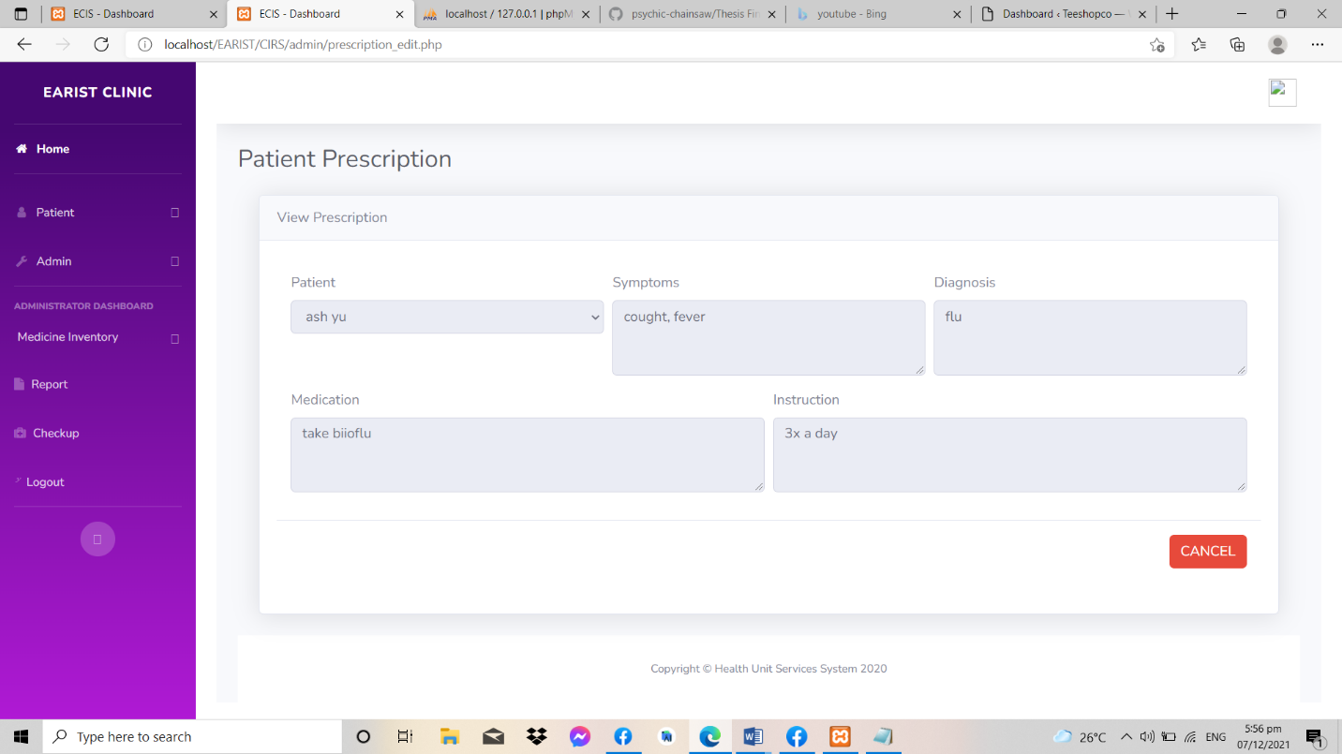

Figure 4.13 – Prescription (Clinic Information Record System)

Prescription form, the same with the medical history form both admin and the staff can view this form, but only the staff can manage this form since they are the ones who will have a verbal interaction towards the patient. Also, both of them can filter the records to gather the information faster unlike the current situation and status of the patient.

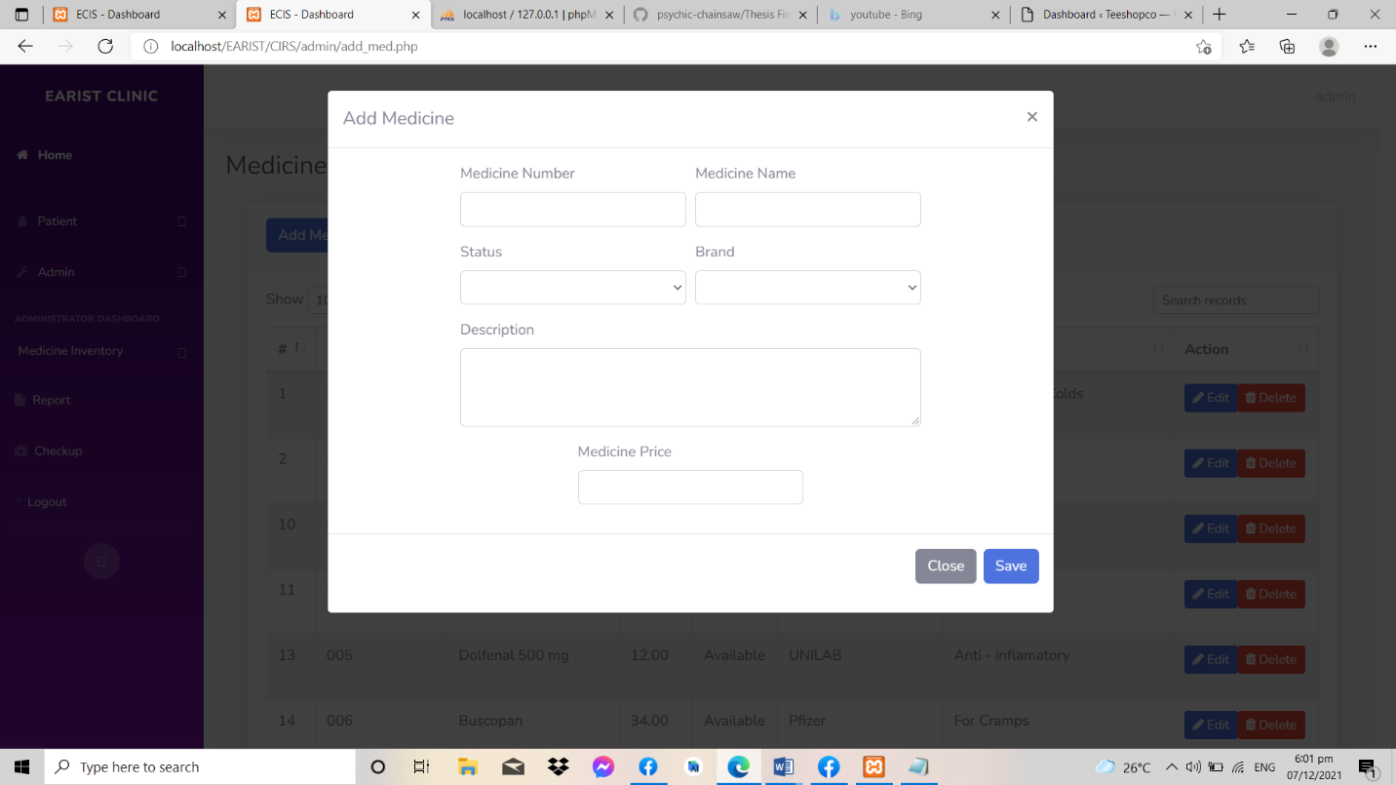

Figure 4.14 – Medicine Inventory Add Medicine (Clinic Information Record System)

Add Medicine, here in this form the stock and data of the medicine is stored. The admin is responsible for updating the medicines record, and take care of the stocks of the medicine, status of the medicine, medicine brand and medicine name.

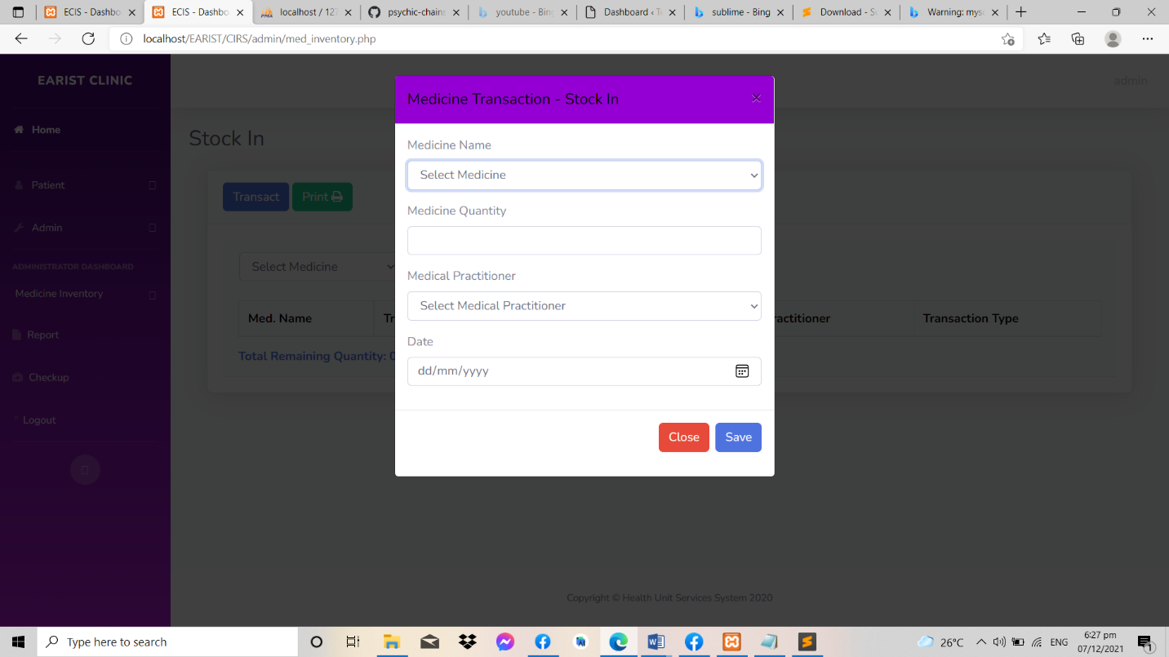

Figure 4.15 – Medicine Inventory Stock In (Clinic Information Record System)

Figure 4.16 shows the medicine inventory stock in transaction. Here, the user may select the specific medicine according to the list of medicines stored in the mother table which is done in the add medicine form. Then the quantity of medicine stocked in, then select medical practitioner and the date. All transactions may be saved and it can be printed.

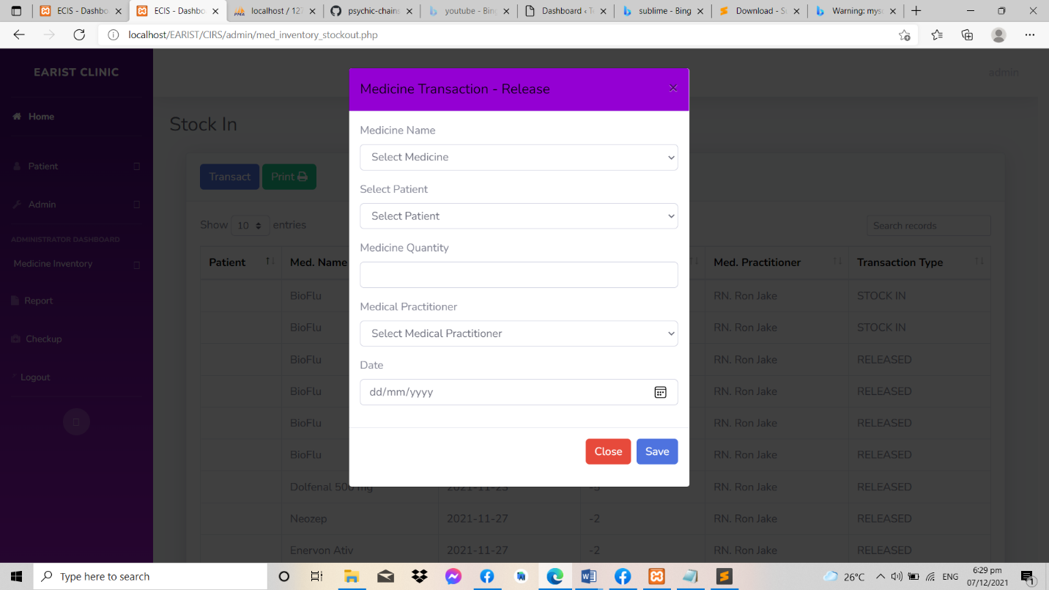

Figure 4.16 – Medicine Inventory Stock Out (Clinic Information Record System)

Medicine Stock Out, based on the figure shown above the transaction of the medicine inventory stock out is all recorded here. Here the user may also select the specific medicine, select patients’ name, quantity of medicine that will be deducted, select the medical practitioner and the date. The same with figure 4.16, there is no edit or delete with these records, it will can be printed also.

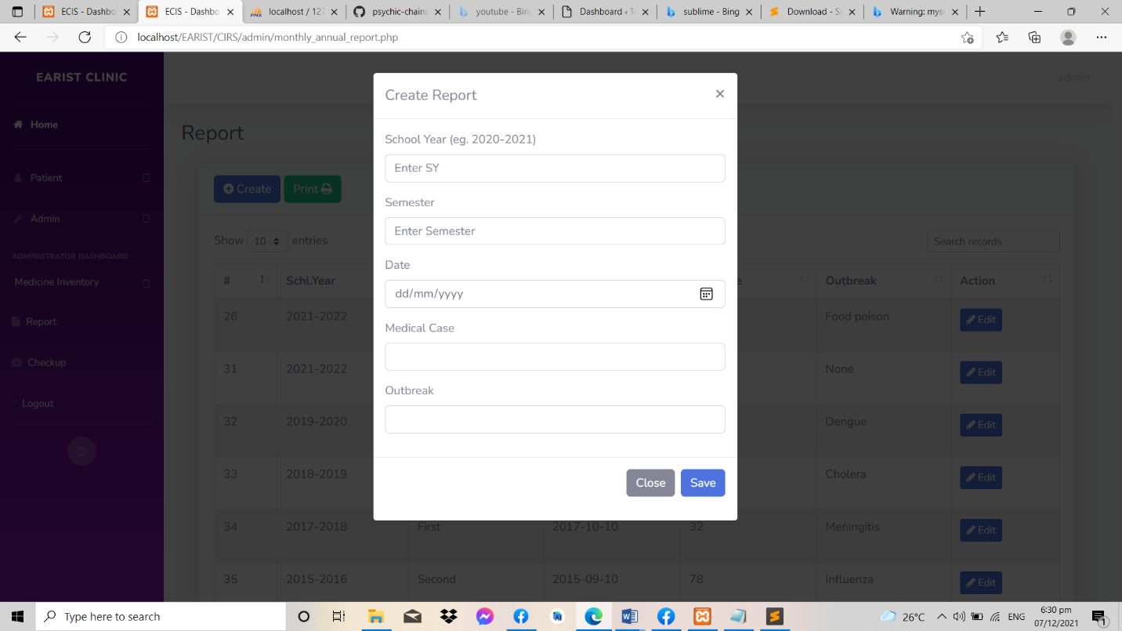

Figure 4.17 – Monthly and Annual Report (Clinic Information Record System)

Monthly and Annual Report form, this form contains monthly and annual report of the clinic department and this form can only be created by the admin, which means only the admin can generate this report from the records stored in the database of the proposed system.

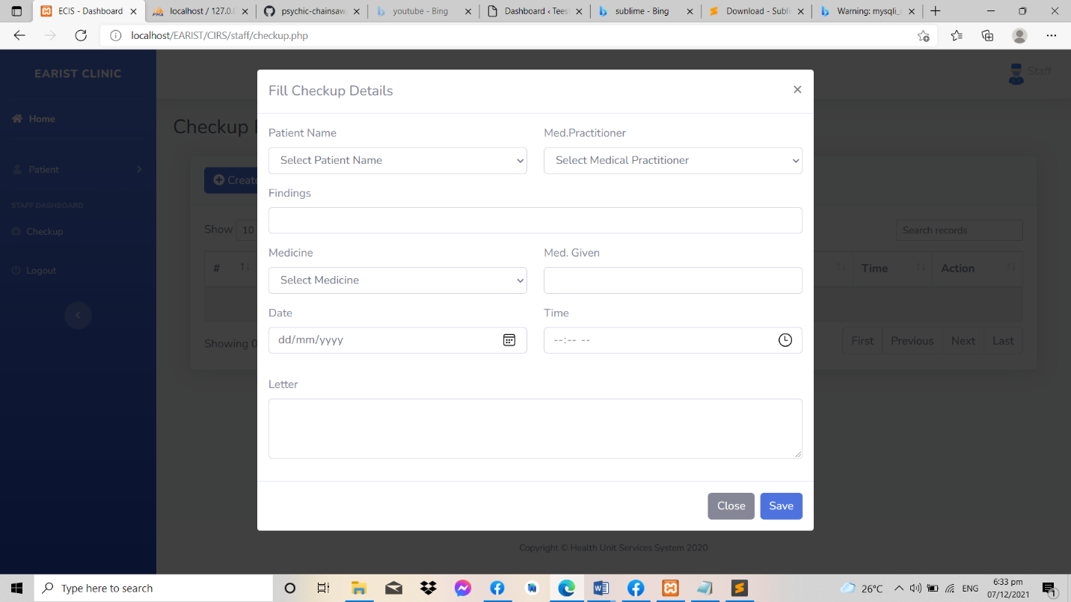

Figure 4.18 – Check-up (Clinic Information Record System)

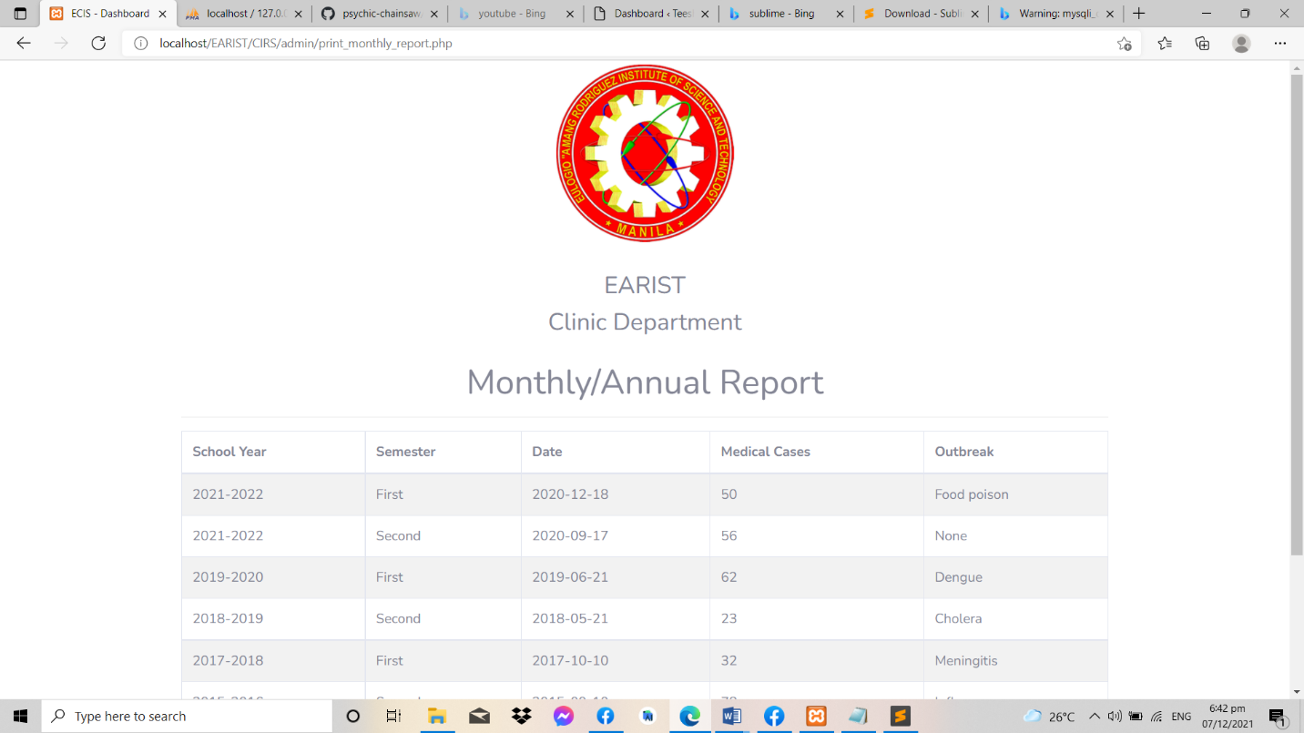

Figure 4.19 – Sample Monthly/Annual Report Form (Clinic Information Record System)

Figure 4.19 shows the sample report form that can be printed by the proposed system. This form contains the record from the current School Year and Semester. Previous School Year and Semester can also be printed if the user wishes to.

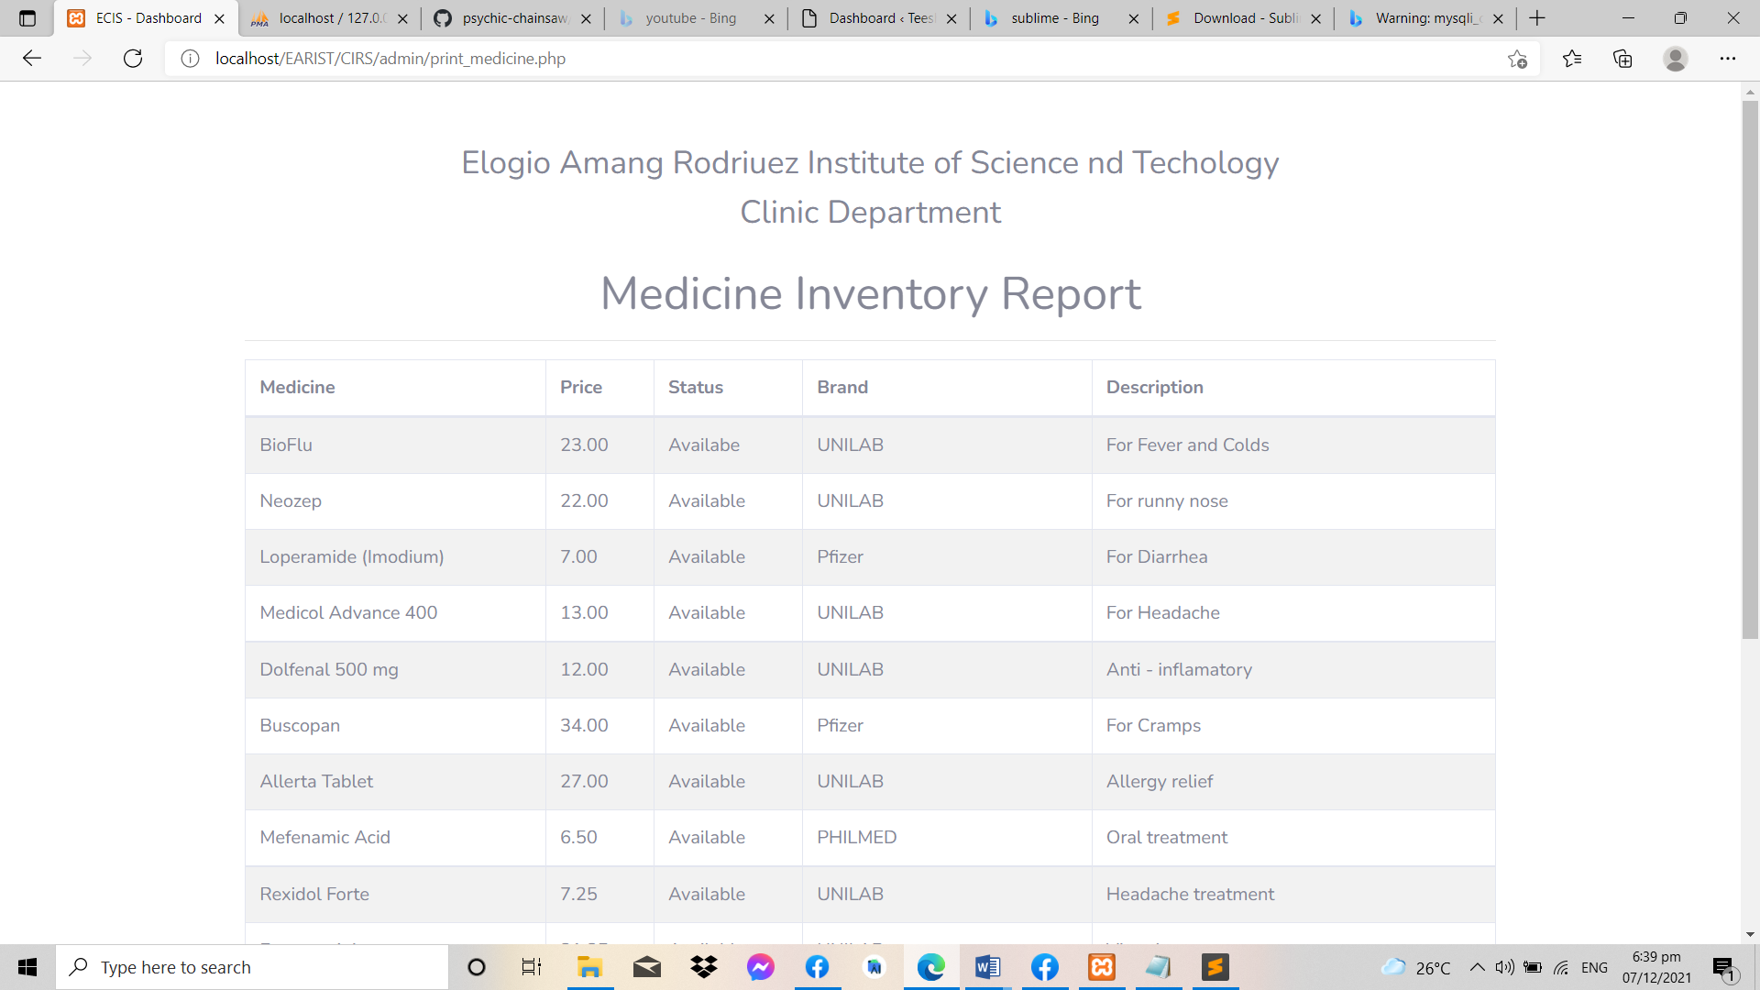

Figure 4.20 – Medicine Inventory Transaction Form (Clinic Information Record System)

In figure 4.20 shows the medicine inventory transaction form. All listed medicine that was released and stocked in can be printed for inventory reporting purpose.

**Testing**

During the testing phase, it will determine the correctness, completeness, and quality of the software that is developed. Validation refers to the process of checking that the developed software meets the requirements specified by the user. The activities involved in the testing phase basically evaluate the capability of the system meets its requirements. The main objective of software testing is to detect errors. Errors occur if some part of the developed system is found to be incorrect, incomplete or inconsistent. It involves the execution of a software component or system to evaluate one or more properties of interest. In general, these properties indicate the extent to which the component or system under test:

* Meets the requirements that guided its design and development.
* Responds correctly to all kinds of inputs.
* Is sufficiently usable.
* Can be installed and run in its intended environments, and
* Achieves the general result to what the stakeholders’ desire.

By testing the functionality of the Login Page, five (5) random individuals were asked to do the task in order to test whether the Login Page is fully working according to what is anticipated. The task includes entering valid credentials, enter invalid credentials, test the output if the fields are empty, test the ‘Remember Me’ button, erase the text entered in the ‘Cancel Button’, and whether the user can only be able to login with a new password after the password is changed. In gathering the feedback regarding the tests task performed. Shown in Table 4.3 is the result of the functionality testing conducted under the Login Page.

Table 4.3 – Login Functionality Testing Result

|  |  |  |
| --- | --- | --- |
| **No.** | **Questions** | **Type – Negative/Positive**  **Test Case** |
| 1 | I can able to login with valid username and valid password. | Positive |
| 2 | I can login with a valid username and invalid password. | Negative |
| 3 | I can login page for both, when the field is blank and submit button is clicked. | Negative |
| 4 | I can see invalid login message. | Positive |
| 5 | I can click the ‘Remember Me’ functionality | Positive |
| 6 | Data in password field is either visible as asterisk or bullet signs. | Positive |
| 7 | I can only login with a new password after I change the password. | Positive |
| 8 | I can login simultaneously with different credentials in different browsers. | Positive |
| 9 | The ‘Enter’ key of the keyboard is working correctly on the login page. | Positive |
| 10 | The font, text, color and color coding of login page is the standard. | Positive |
| 11 | I can erase the text entered in the ‘Cancel Button’. | Positive |

Based on table 4.3, it shows the items corresponds to the task performed by the participants or actors. In all questions stated above, 100% answered a positive feedback, which means that all five (5) participants were able to perform the tasks successfully.

In testing the functionality of the Admin Module, five (5) participants were asked to do the task in relation to the function of administrator role. These tasks include managing user account, view medical record, view patient detail, create report, manage medicine inventory, manage appointment, and manage check-up. Table 4.4 will show the functionality testing of the Admin Module.

Table 4.4 – Admin Module Functionality Testing Result

|  |  |  |
| --- | --- | --- |
| **No.** | **Questions** | **Type – Negative/Positive**  **Test Case** |
| 1 | I can view all patient records. | Positive |
| 2 | I can view the patient’s medical history. | Positive |
| 3 | I can view prescription. | Positive |
| 4 | I can manage medicine inventory. | Positive |
| 5 | I can notify students, professors and guardian. | Positive |
| 6 | I can manage check-up detail. | Positive |
| 7 | I can register and manage user account. | Positive |
| 8 | I can manage reports. | Positive |
| 9 | I can login with the administrator credentials. | Positive |
| 10 | I can logout successfully without errors. | Positive |

As presented in table 4.2, each question that correspond to the tasks performed by the actors or participants in all items, 100% of the participants answered POSITVE, which means all five (5) participants were able to perform the tasks successfully.

In testing the functionality of the Staff Module, five (5) participants acted as the staff and were also asked to test the functions of the staff role. The task that was included are managing patient records, manage patient’s medical history, manage prescription, view medicine inventory, create an appointment, and manage check-up. Table 4.5 will show the functionality testing of the Staff Module.

Table 4.5 – Staff Module Functionality Testing Result

|  |  |  |
| --- | --- | --- |
| **No.** | **Questions** | **Type – Negative/Positive**  **Test Case** |
| 1 | I can input patient record. | Positive |
| 2 | I can input medical history record. | Positive |
| 3 | I can input prescription. | Positive |
| 4 | I can manage patient record, medical history, prescription. | Positive |
| 5 | I can manage check-up. | Positive |
| 6 | I can view and manage medicine inventory. | Positive |
| 7 | I can notify students, professors and guardian. | Positive |
| 8 | I can update, delete and edit existing record. | Positive |
| 9 | I can log out from the system smoothly. | Positive |

Based on Table 4.5, each question that correspond to the task performed by the participants. In all items, 100% answered POSITIVE, which means all five (5) participants can able to do the tasks successfully.

**Evaluation**

The researcher conducted a functionality and usability to find out how functional, time efficient and usable the system is. The evaluation process is done in the testing phase of the system. After doing all the tasks, each participant answered the functionality questionnaire the researchers prepared. After which, usability test is used to help determine the satisfaction rating and feedback of the participants to the overall system functionalities and features (see Appendix B). The said instrument has a like scale to quantify the user’s feedback, with 5 as the highest score which means Strongly Agree, and 1 as the lowest Score which means Strongly Disagree. There were a total 5 participants comprised with two (2) admin user, three (3) staff user.

|  |  |  |  |  |  |  |  |
| --- | --- | --- | --- | --- | --- | --- | --- |
| No. | Pre-Questionnaire | Score | | | | | Mean |
|  |  | P1 | P2 | P3 | P4 | P5 |  |
| 1. | Does your current system are easy to use? | 3 | 3 | 4 | 4 | 3 | 3.4 |
| 2. | Is your excel base system is good base on its speed on retrieving data? | 2 | 2 | 4 | 3 | 4 | 3 |
| 3. | Does your current system provide clear information? | 1 | 3 | 4 | 3 | 5 | 3.2 |
| 4. | The system has enough screen for its activity? | 1 | 3 | 4 | 4 | 4 | 3.2 |
| 5. | Can your current system execute without interruptions? | 4 | 4 | 4 | 4 | 4 | 4 |
| 6. | Does it facilitate the analysis of students’ medical record? | 3 | 4 | 5 | 3 | 5 | 4 |
| 7. | The system provides complete information? | 3 | 4 | 3 | 3 | 3 | 3.2 |
| 8. | Is it easy to insert information into electronic records? | 2 | 5 | 5 | 2 | 3 | 3.4 |
| 9. | Is the information divided in a consistent manner? | 4 | 5 | 4 | 4 | 2 | 3.8 |
| 10. | Does it facilitate the medicine inventory? | 2 | 4 | 5 | 2 | 4 | 3.4 |
| *Scoring: 1 – Strongly Dissatisfied 2 – Dissatisfied 3 – Neutral 4 – Satisfied 5 – Strongly Satisfied* | | | | | | | |

Table 4.6 – Usability Test Scores per Item Interpretation for pre-survey

Table 4.6 – shows the scores of each participant and also the mean of each question item. In item 1, the average mean is 3.4 which means that most participants find the current system slightly easy to use. Some of the participants were dissatisfied when it comes to speed of retrieving data using excel base system. In question number 3, one user said that the current does not provide clear information while others were satisfied. In question number 4,